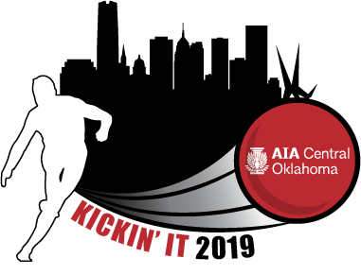
Saturday, June 8, 2019
PCAA Athletic Fields
3100 West Britton Road, OKC

SPONSORSHIP OPPORTUNITIES

___ GOLD SPONSOR $1,000
- Company recognition at the event and signage in the pavilion
- Company Logo on AIA Web Site and Social Media Sites
- Complimentary Kickball Team of 12 players.

___ SILVER SPONSOR $650
- Company Logo on all materials related to the event
- Invitation to put up a tent and hand out drinks and snacks to Kickballers
- Company Logo on AIA Web Site and Social Media Sites
- 6 Complimentary Kickball Players or Spectators

___ BRONZE (STATION) SPONSOR $425
- Company name on all materials related to the event
- Company Logo on a station sign
- 1 Complimentary Shooter

___ INKIND SPONSORSHIP (I will donate: _______________________)
- Company name listed as a prize sponsor on materials related to the event

Name: ________________________________ Company: ___________________________________
Email: _________________________________Phone:______________________________________
Email to: aiacoc@cox.net

