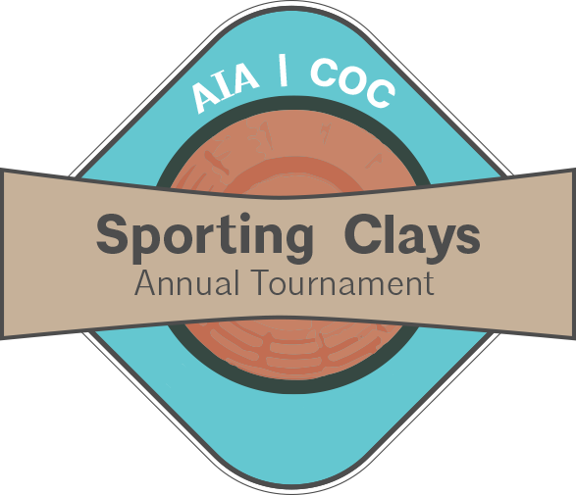
Friday, February 22, 2019
Silverleaf Shotgun Sports

SPONSORSHIP OPPORTUNITIES

___ GOLD LUNCH SPONSOR $1,000
- Company recognition at the event and signage in the lunch pavilion
- Company Logo on AIA Web Site and Social Media Sites
- 4 Complimentary Shooters

___ SILVER (SNACK) SPONSOR $650
- Company Logo on all materials related to the event
- Company representative can be onsite to hand out drinks and snacks to participants
- Company Logo on AIA Web Site and Social Media Sites
- 2 Complimentary Shooters

___ BRONZE (STATION) SPONSOR $425
- Company name on all materials related to the event
- Company Logo on a station sign
- 1 Complimentary Shooter

___ INKIND SPONSORSHIP (I will donate: _______________________)
- Company name listed as a prize sponsor on materials related to the event

Name: ________________________________ Company: ___________________________________
Email: _________________________________Phone:______________________________________
Email to: aiacoc@cox.net

