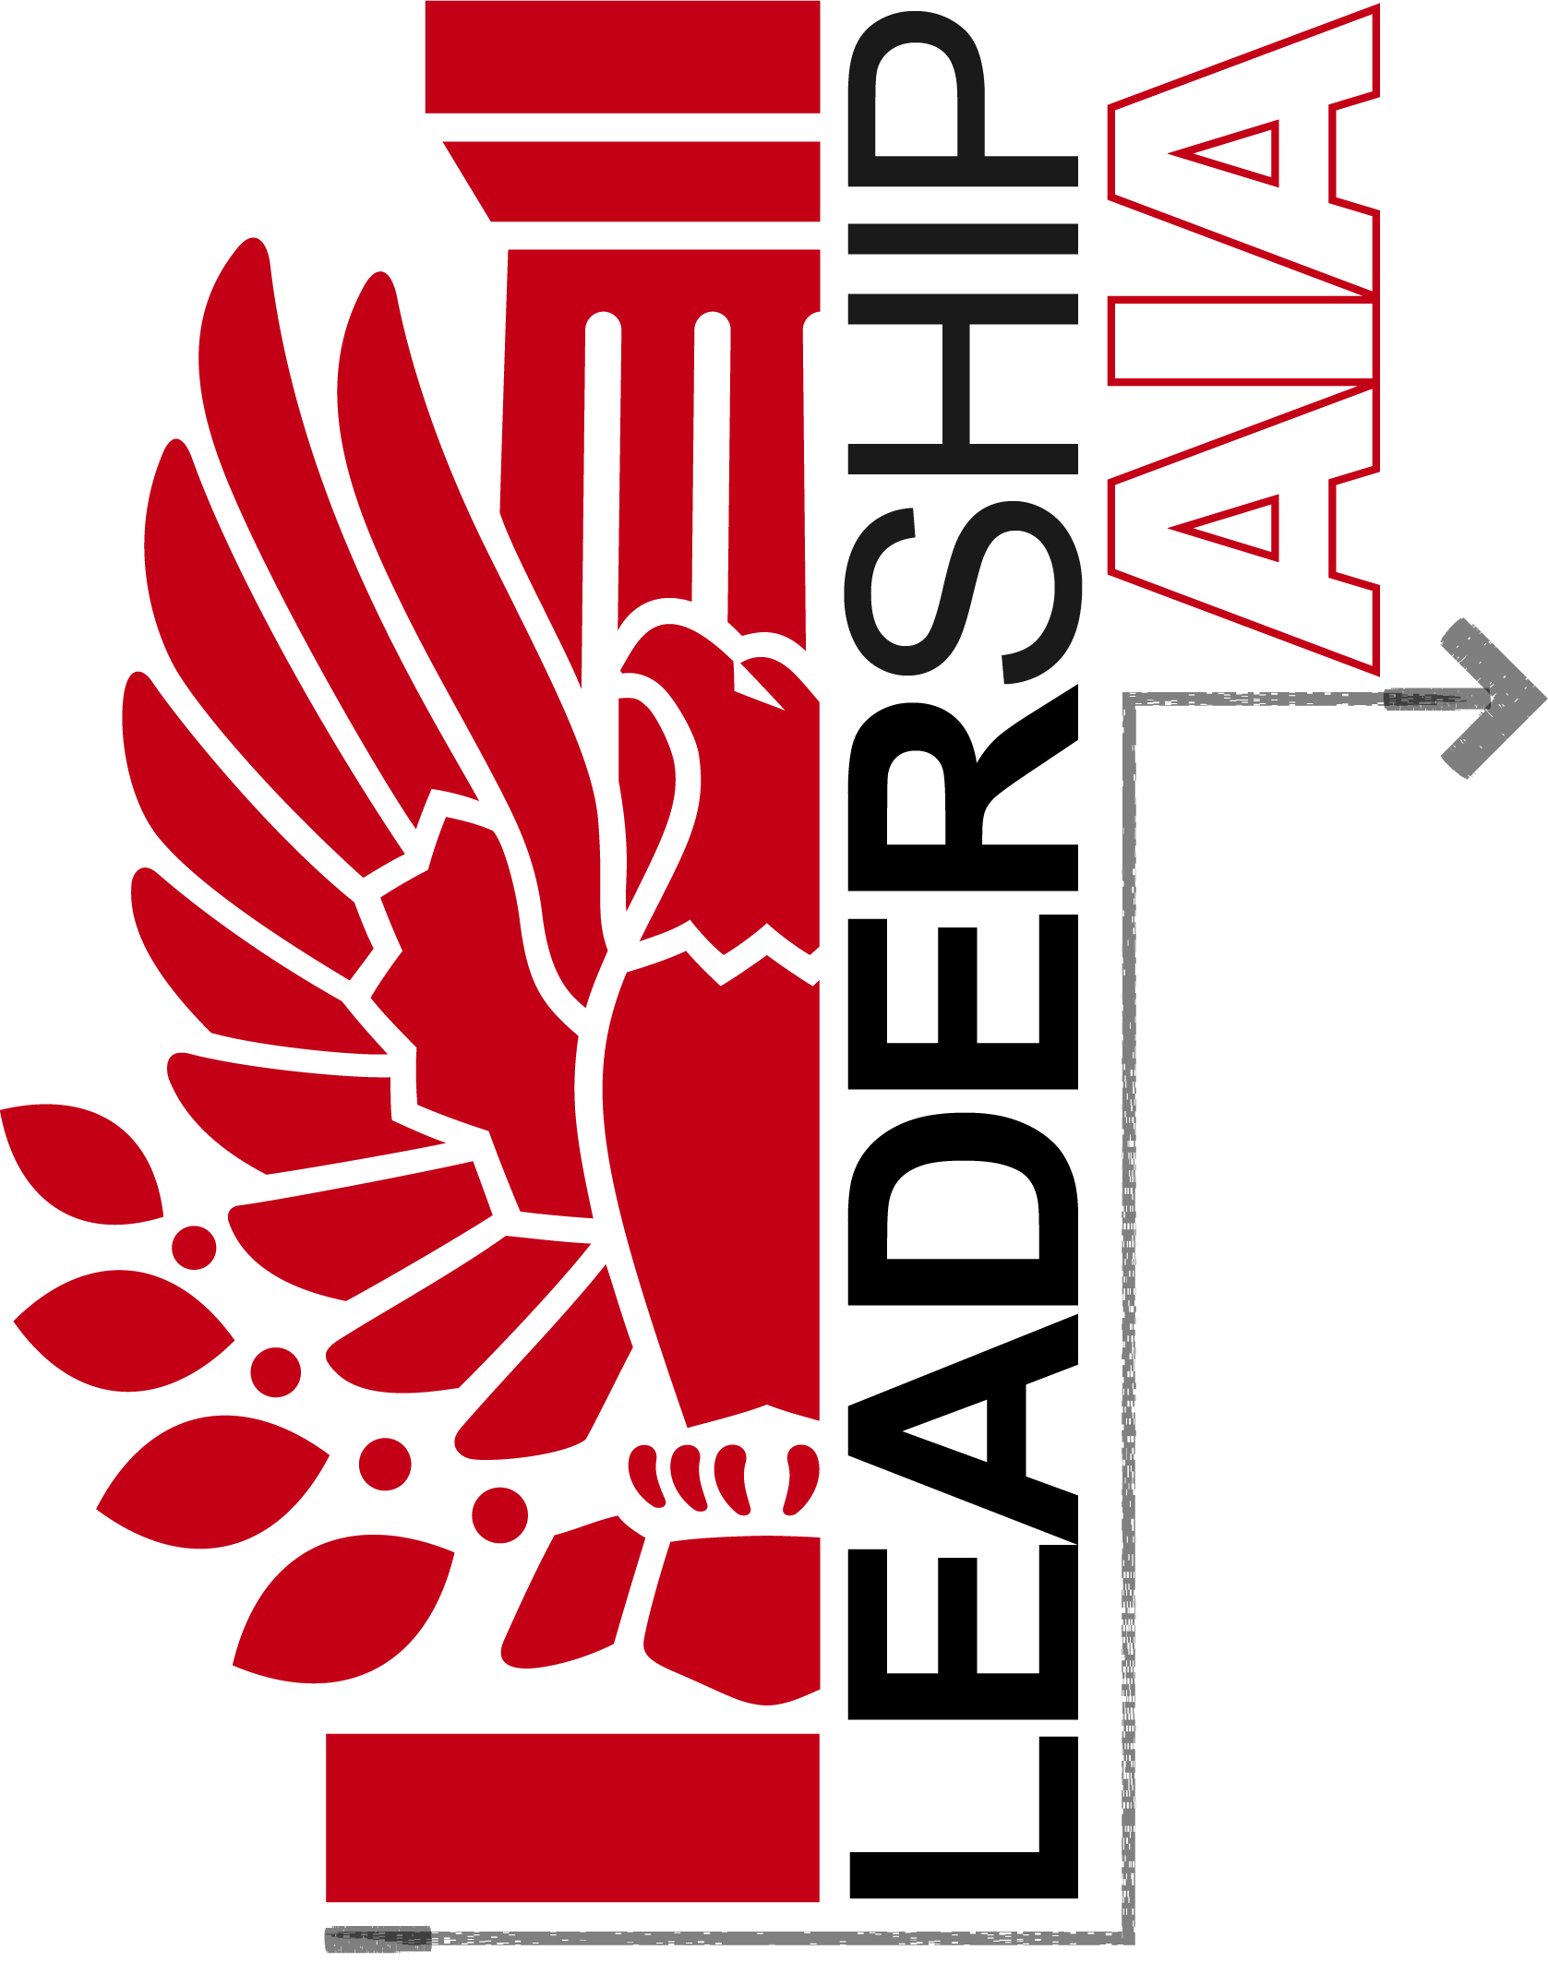
Application for Leadership AIA, Class IV

Program Requirements
- Candidates must be an AIA or Associate AIA member of AIA Central Oklahoma, AIA Eastern Oklahoma or AIA North Central Oklahoma Section
- Tuition is $650
- Up to 16 participants will be selected.
- Selected participants are expected to attend all scheduled sessions and complete all homework. The opening session on March 29 is mandatory. Participant can miss one class and still graduate but are encouraged to attend all classes.

Important Dates

March 1 Applications due, including a commitment letter from the firm

March 4 Selections announced

March 29 Tuition Due (can be made in payments if needed)

2019 Leadership AIA Schedule and Program

March 29  (Stillwater) | What is a Leader? What kind of leader are you?
April 17  (OKC) | Government Advocacy / Media / Marketing
May 10  (Tulsa) | Project Management & Delivery
July 12  (Stillwater) | Social Architecture / Community Service
August TBD | Community Service Day
September 13  (TBD) | Design Legacy and Mentorship
October 4 | Graduation at AIA Oklahoma Conference

2019 APPLICATION
______________________________________________________________________
General Information

______________________________________________________________________
First Name Middle Last

______________________________________________________________________
Home Address

______________________________________________________________________
City State Zip

______________________________________________________________________
Email Address Cell Phone

______________________________________________________________________
Current Employment

______________________________________________________________________
Firm Name

______________________________________________________________________
Business Address

______________________________________________________________________
City State Zip

______________________________________________________________________
Business Phone

______________________________________________________________________
Date Your Employment Began Current Title

Application – Page 2

1. Please provide a short bio.

2. Have you engaged in any previous leadership training? If so, please describe below and list when the training occurred.

3. What specific skills or knowledge do you hope to gain from your participation in Leadership AIA?

Application - Page 4

______________________________________________________________________

I fully understand the $650 tuition requirement and the expectation to attend all scheduled sessions for Leadership AIA and agree to fulfill those requirements if selected. I am a current member of AIA Central Oklahoma, AIA Eastern Oklahoma or AIA North Central Oklahoma Section and will continue to be a member in good standing for the duration of the program and for at least 5 years following the Leadership AIA graduation.

______________________________________________________________________Applicant's Signature Date

______________________________________________________________________
Application Deadline – March 1, 2019

Candidates must submit:

❑ Application, completed and signed
❑ Commitment Letter from the applicant's employer stating that he / she has the ability to participate in all Leadership AIA programs.

Return all of the above to:
Melissa Hunt or Lindsey Ellerbach
aiacoc@cox.net chapter@aiaarchitects.com

