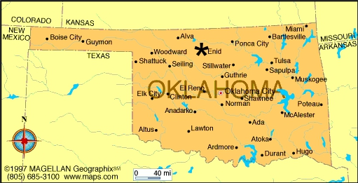
AIA Oklahoma Conference
on Architecture
Blueprint for a Better Oklahoma
Call for Speakers

The AIA Oklahoma Conference on Architecture Planning Committee is looking for speakers for the 2018 Conference set to take place Thursday, November 8 and Friday, November 9 in Enid, Oklahoma. Our theme for 2018 is Blueprint for a Better Oklahoma.

We are looking for proposals that will fit our theme, Blueprint for a Better Oklahoma and fall under one of these categories:

1. Emerging Professionals 6. Construction / Design Build
2. Business Best Practices 7. Alternative Practice
3. Design 8. Community Development
4. Technology 9. Community Planning / Urban Design
5. Community Engagement 10. Historic Preservation

The Conference Committee will review each submitted proposal and get back to you via email whether or not your workshop has been selected.

Local speakers from Oklahoma will be given free conference registration for speaking. Speakers outside of Oklahoma will be given one night hotel and coach airfare or mileage to attend along with free conference registration. We will not provide travel or hotel for vendor programming.

How to Submit Proposals

To be considered for a presentation please fill out the following form in its entirety and submit no later than May 1. Each program is 60 minutes long. All presenters must provide AIA Oklahoma with a digital copy of their presentation as well as workshop handouts by October 15, 2018. Please send handouts and presentation content to aiaoklahoma@cox.net.

If you have any questions, please contact AIA Oklahoma at 405-948-7174 or 918-583-0013 or aiaoklahoma@cox.net

A. PRESENTER CONTACT INFORMATION

FIRST NAME: LAST NAME:

DESIGNATION: COMPANY:

EMAIL: STREET ADDRESS:

CITY: STATE: ZIP:

PHONE: CELL:

Will you be joining us for the Conference on the day of your presentation? ___YES ___NO

B. COURSE DIRECTORY Select one or more from the list below

_ Building Science & Performance _ Practice
_ Design & Design Services _ Project Management
_ Legal _ Project Types
_ Materials & Methods _ Sustainable Design
_ Other __________________________________________________________

C. Workshop Track
_________________________________________________________________

D. COURSE TITLE
__________________________________________________________________

E. PRESENTATION TIME & PREFERENCE

_ Thursday Morning _ Thursday Afternoon
_ Friday Morning _ Friday Afternoon
_ No Preference

F. DESCRIPTION

G. AUDIO VISUAL NEEDS

_ Projector _ Microphone _ Other _______________________________

H. LEARNING OBJECTIVES

Four learning objectives are required by AIA CES. A learning objective is an explanation of the learning outcomes of the course, they should clearly express what the adult learner will be able to do after taking the course. For the course to be eligible for Health, Safety, and Welfare (HSW) credit, 3 of the 4 objectives must reflect HSW topic areas.

Objective 1:

Objective 2:

Objective 3:

Objective 4:

I. Additional Presenters / Panelists

First Name: Last Name:

Designation: Company:

Email: Phone:

First Name: Last Name:

Designation: Company:

Email: Phone:

J. Biography

Please provide a brief overview of your background (and that of the other panelists) and expertise in paragraph form.

K. Submit

Please title this application by the name of your program (i.e. Materials 101.docx) and submit it to aiaoklahoma@cox.net.

